

CST3511 Internet Scale Applications and Development

BEng Computer Systems Engineering

Topic: Web development

Student Name - MISIS:

Mohammad Sinan – M00696779

Tutor:

Jaspreet Singh

Date: 13th December 2020

Contents

Abstract 3

Introduction 3

Design 3

Database design 3

Architecture 4

User interface design 5

Sign-in page 5

Sign-up page 5

Home page 6

Details of third party data sources 6

Implementation 7

Website 7

Sign in page 7

Sign up page 7

Home page / Calculating Hub 8

Final page / Food Hub 9

Database connection 9

Gantt chart 9

Conclusion 10

References 10

# Abstract

The report will give an overall view of the website and its working. The website comes under health and fitness where it helps the user to calculate the amount of protein, he/she needs to intake and depending on the result the website allows to make a food search depending on their need. The report will give a brief introduction on the website. The report will show how this website was created by describing the database design, the architecture, its user-interface on how it should be used and also the third-party data sources. The report will show the final product screenshots on the implementation. Finally, it shows a Gantt chart where it shows how much time it took to complete this website.

# Introduction

The protein hub is a website that delivers a protein intaking food planning solution for actively working out personals. The website allows the user to create their own account to access the functionalities of the website by filling all the required details properly. After being registered successfully the user will be navigated automatically to the index page to sign in on submit. On the index page if the user enters a wrong email or password which does not exist in the database the user will be alerted with a message to try again which was created using JavaScript , after filling out the email address and password successfully the user will be navigated to the home page where the user can calculate his or her protein intake by filling in the required details asked these results are after doing a good research on how much protein a male or female has to take in, these calculations are done using java server faces managed beans and on the navigation bar it allows to sign out from the account by clicking on the sign out option also by click on the covid-19 updates it will show the total confirmed cases, deaths and recoveries. Then there is a drop drown arrow to navigate to the food search page on this page this will allow the user to search all kinds of food they type in; these results are fetched using the third-party API where all the food details are stored in their database. After searching the user will be able to select from the list to create a total value of the required amount of protein they have calculated.

The report will now show how the website has been implemented and how it has been improved from the proposal. The database design adds the user details who visit the website to add to the derby server, the interface designs a brief layout on what was hoped for from the designed website, and details of third-party data sources to entitle the purpose behind the website’s functions. The implementation will establish the database connectivity, the API calls, the utilization of AJAX, servlets, JavaScript and java server faces managed beans. The report will also overlook the flexibility of the website considering the API call and the CSS designs.

# Design

## Database design

The website will be using Derby database to store all user details like name, email address(PK), password, date of birth, mobile number, address and security questions of each user. Using this database, all details will be updated in real time. The website connects the database base through java servlet and to store in the user input the servlet will be called on either HTML/XHTML pages. The servlet is designed in a way to get rid of errors and has a catch phrase to catch any errors occurred and will alert the user about it. Here is the ER diagram showing the database model.

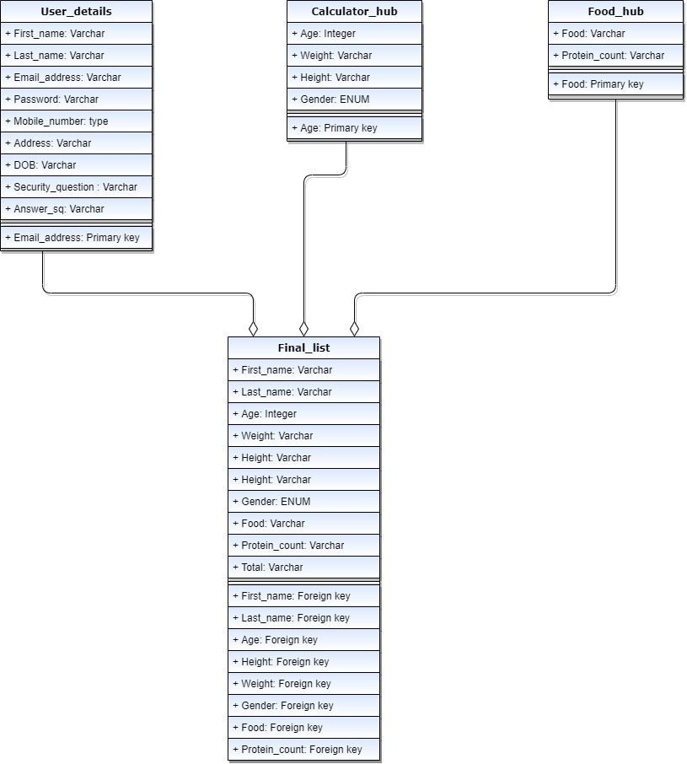

## Architecture

Via the use of databases, the website can retrieve and display the data links. The database will consist of numerous numbers of tables which depends on the website. This will show stored data for example, a table will entitle the information of food with all nutrition facts and their source. In order to retrieve the required data from the website that holds the information and statistics, the server side will mainly initialize a fetch command. The data will be stored when fetched and then projected on the server side, which is a local host. The website then sends a request for the data, allowing the storage to be received by the result, then sends it back for execution to the website. Therefore, the website would have the result displaying the name of the food and their nutrition facts depending on the user input.

Here is the website architecture shown.

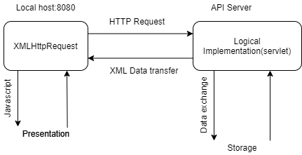

API Architecture

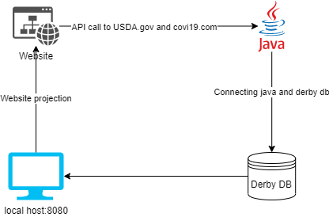

Website architecture

## User interface design

This is how the UI/Wireframe is going to be looking like on the website and it also explains briefly what each page of the website will be having and the also talks about the added features in it. All these wireframes are shown from the proposal itself. The below shown screenshots are not finished website images.

### Sign-in page

This is the sign up page where the user will be asked to type in the email id and password if he/she is already registered or else when clicked on the sign-up option they can register to create an account.

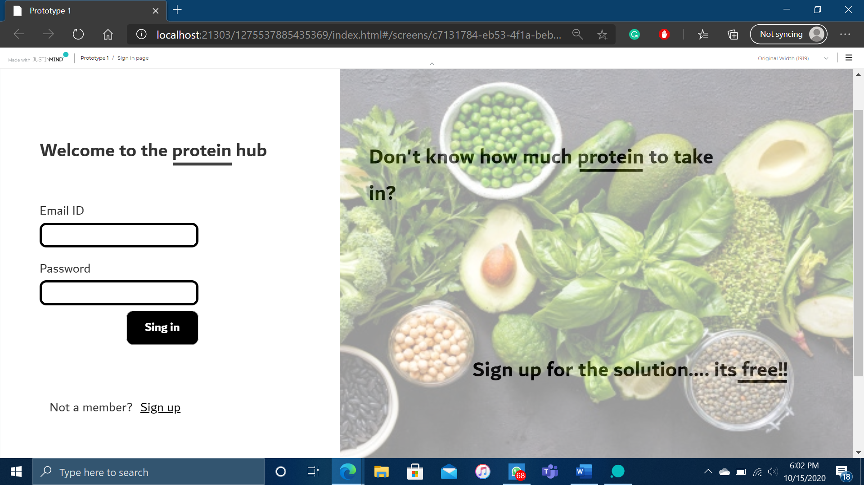

### Sign-up page

This is the page where the user will be allowed to create a personal account by filling in the required fields on the page.

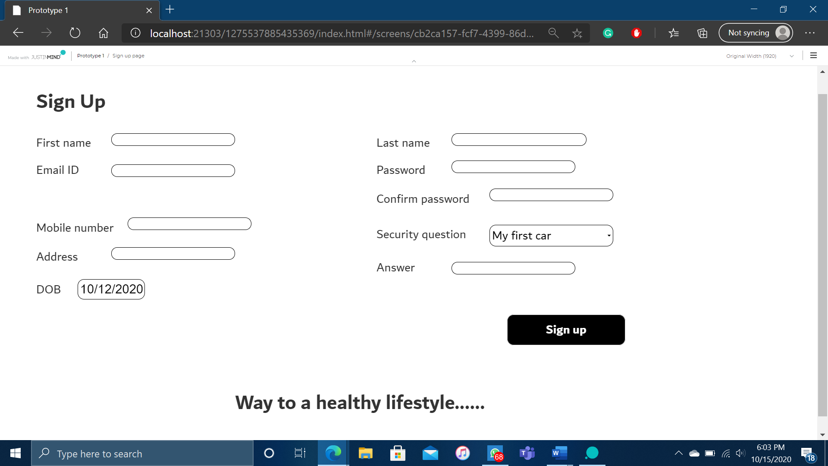

### Home page

This is the main page where it shows all the features of the website i.e. the protein calculator known as the calculator hub . There will also be an extra page to search all the food details also a food selection section known as the food hub. Both the pages will also show a coronavirus update.

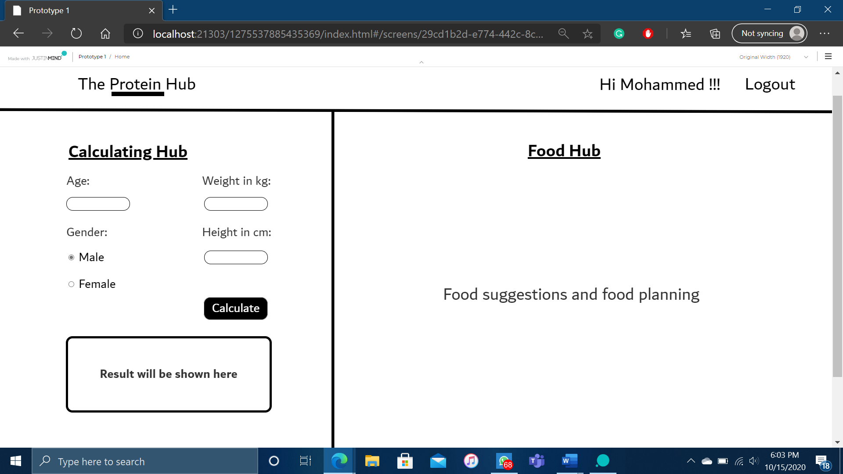

## Details of third party data sources

The website uses two API’s one for getting food nutrition details and the other one for coronavirus updates.

The fdc.nal.usda.gov API provides all kinds of food nutritional details like their protein, carbohydrates, magnesium, etc. The website provides an API documentation to provide the connection for the website. the website connects the API using JavaScript and that JavaScript file will be connected to the html page.

The covid-19.api.postman.com provides all kinds of coronavirus API from those the protein hub will only show the total world results on confirmed cases, deaths and recovered.

# Implementation

## Website

The website was created on HTML with different CSS sheets for each page whereas only the home page uses an XHTML page. Each website has its on functionalities, on the calculating page the website uses java server faces managed beans to do the calculation, the calculation and the values to calculate has been thoroughly studied and referenced from the academy of nutrition and dietetics, American college of sports medicine and the dietetics of Canada. On all API required pages they were called using JavaScript with ajax.

### Sign in page

Created using HTML and have done a beautiful user-friendly CSS, is connected to a servlet for validating through the database before signing in to the account. Once clicked on sign up link the user navigates to the sign-up page.

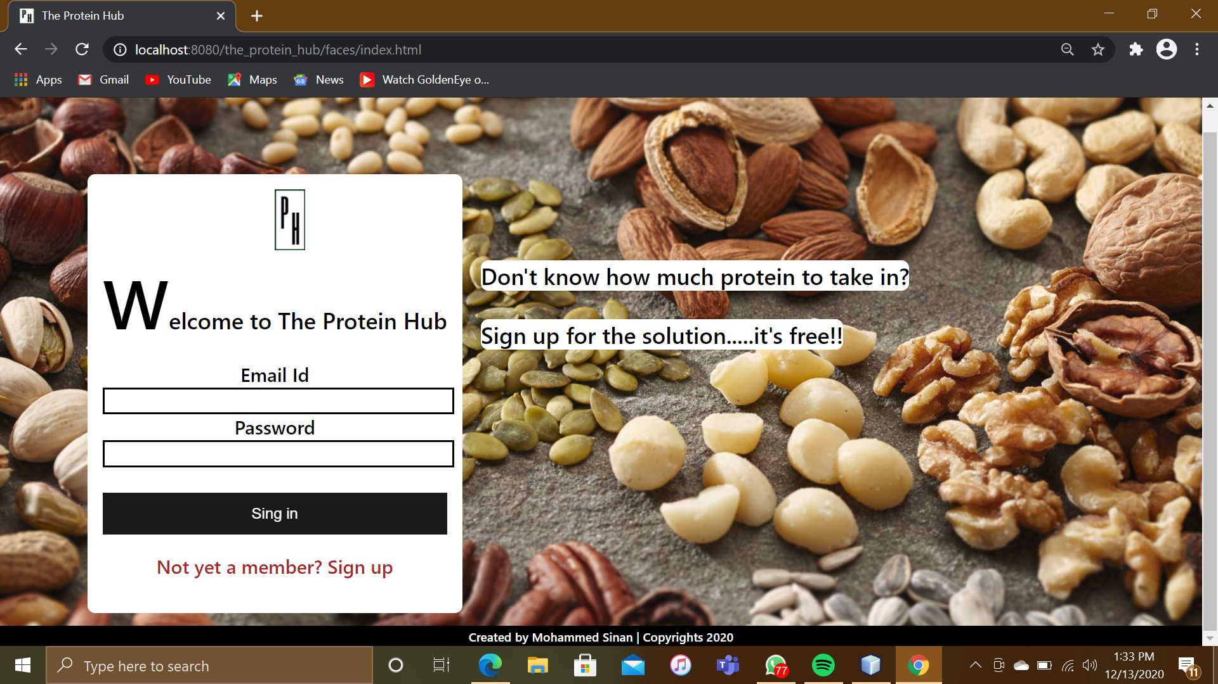

### Sign up page

This page is used to create an account for the user, once they fill in all the fields as requested. The user will be registered successfully and will be alerted with a message which was created on JavaScript. This webpage is connected to a servlet to store the user details on the database.

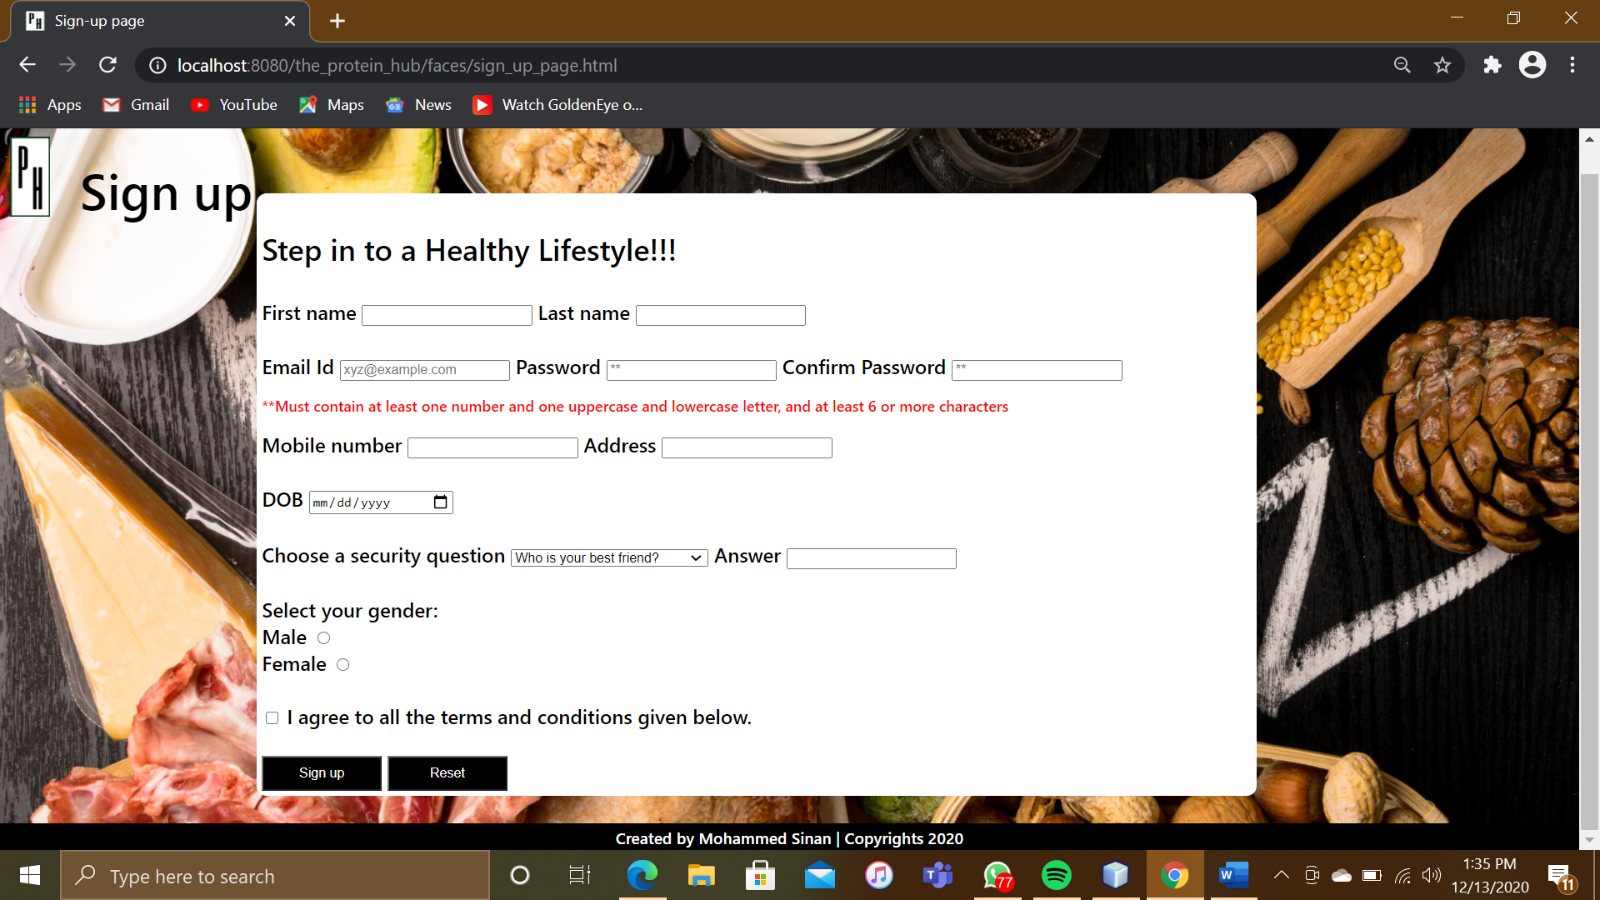

### Home page / Calculating Hub

This is the page where the user can calculate their protein intake for a day by filling in all the required fields. This webpage was created using XHTML and CSS and is connected to java server faces managed beans for doing the calculation. Once clicked on the beautiful animating drop down aarrow the user will be navigated to the search bar allocated page.

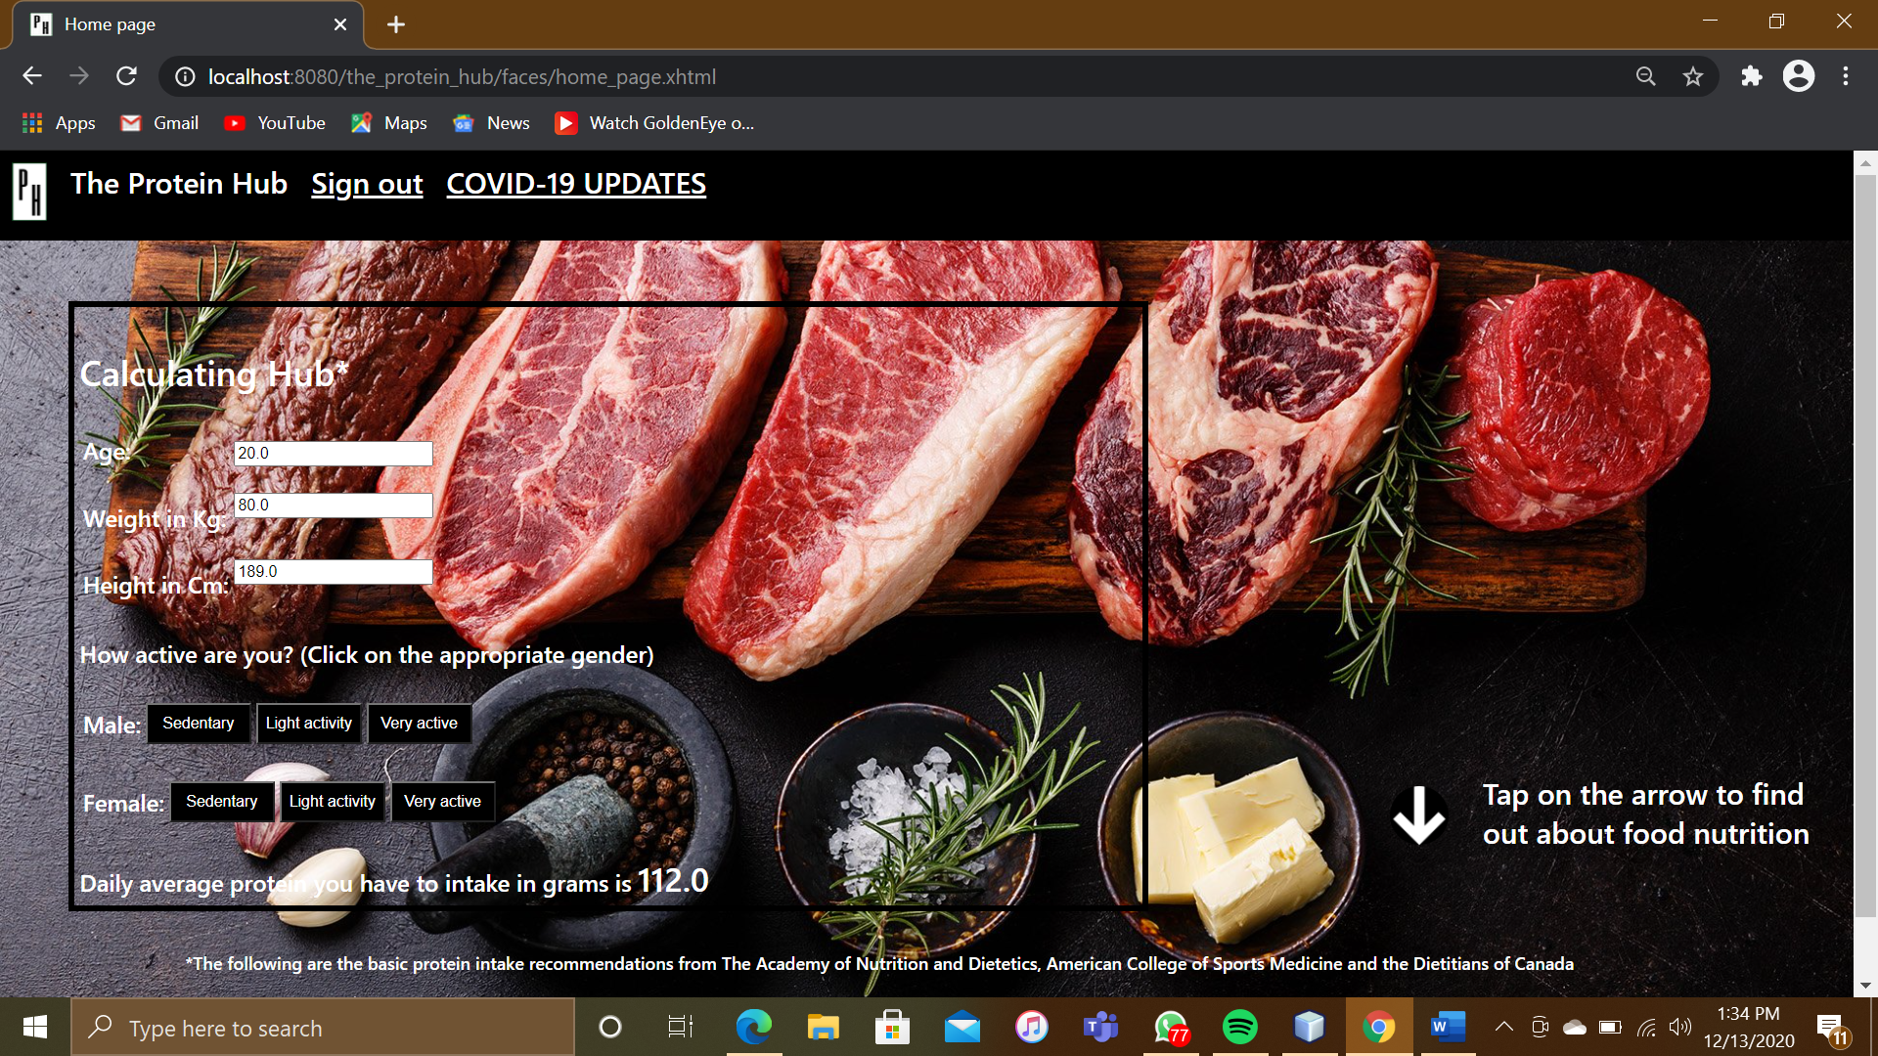

### Final page / Food Hub

This page was created using HTML and CSS, and is used to search about the food nutrition’s and their benefits. These results are coming from the usda.gov API which has been connected to the webpage using JavaScript.

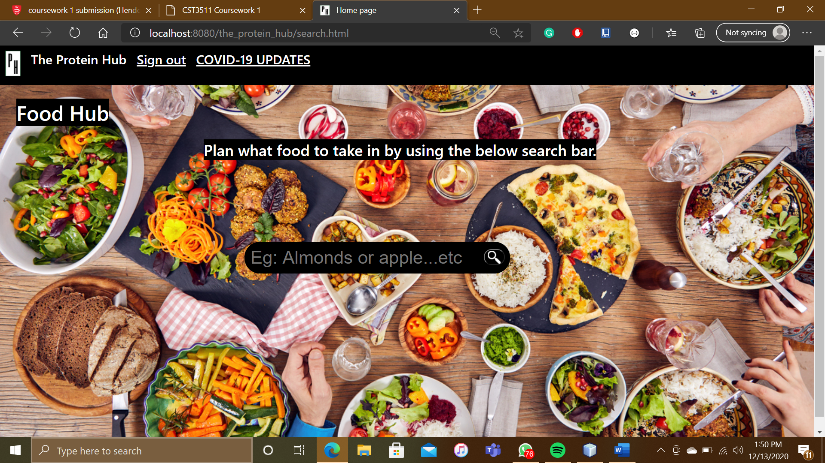

## Database connection

The database has been connected to website using java servlet, two servlets has been used in the website one for registering user details into the derby database other servlet is used to do a validation for signing in the user by doing validation query on the database. Both these servlets are connected on respected html pages.

I have added my SQL table as a notepad file on my project zip folder on a database folder named as proteinhub.sql.

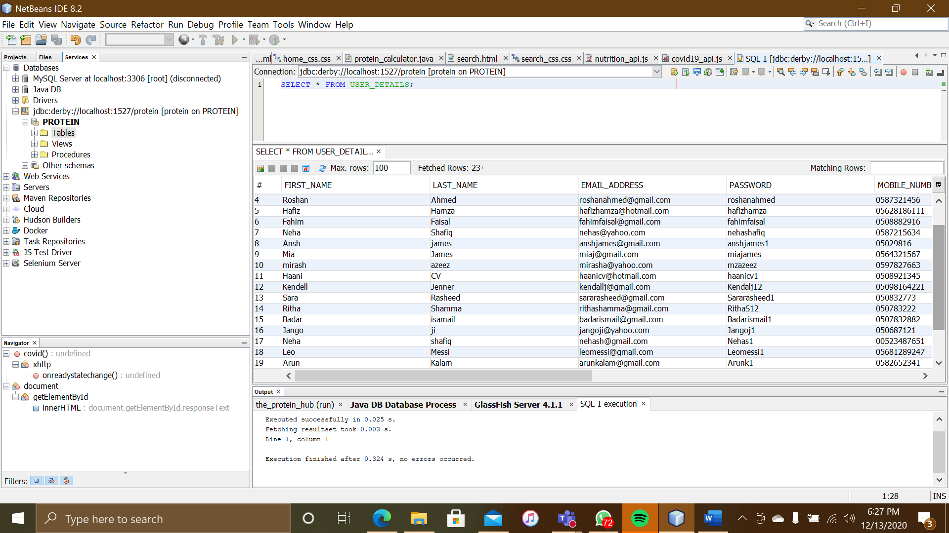

# Gantt chart

This is what the Gantt chart looks like and has gone according to the plan.

|  |  |  |
| --- | --- | --- |
| Planning | Start date | End date |
| Project Planning |  |  |
| Decide the topic | 12th Oct |  |
| Project proposal | 13th Oct | 22nd Oct |
| Implementation |  |  |
| Html coding | 25th Oct | 7th Nov |
| CSS | 8th Nov | 14th Nov |
| Derby Database | 15th Nov | 23rd Nov |
| Connect to third party API | 24th Nov | 30th Nov |
| Testing |  |  |
| Test environment setup | 1st Dec | 2nd Dec |
| Test plan | 1st Dec | 2nd Dec |
| Video demonstration | 3rd Dec | 3rd Dec |
| Documentation |  |  |
| Report writing | 3rd Dec | 10th Dec |
| Submission | 14th Dec |  |

# Conclusion

To finalize, the idea behind the protein hub was for to people to depend on the website for all their meal-planning details by calculating their protein intake by filling the forms required and get all the food nutrition’s by searching any kind of food on the functioning search bar implemented. The main objective is to make people follow a healthy way of living and hoping people will benefit from this idea.

Within the signs of improvements, creating a rather flexible search bar and result to create a more feasible result that is executed once the user searcher before the API call. Requires to keep the page at 70%-80% zoomed in to experience the best view of the website.

# References

2020. [online] Available at: <https://fdc.nal.usda.gov/api-guide.html> [Accessed 12 December 2020].

Cataldo, D. and Blair, M., 2020. *How Much Protein For Muscle | Repair, Growth, Maintenance*. [online] Acsm.org. Available at: <https://www.acsm.org/all-blog-posts/certification-blog/acsm-certified-blog/2020/09/14/how-much-protein-for-muscle-repair-growth-maintenance> [Accessed 12 December 2020].

Covid-19-apis.postman.com. 2020. *Postman COVID-19 API Resource Center | List Of Apis And Blueprints*. [online] Available at: <https://covid-19-apis.postman.com/> [Accessed 12 December 2020].

GitHub. 2020. *Github: Where The World Builds Software*. [online] Available at: <https://github.com/> [Accessed 12 December 2020].

health, f. and calculator, p., 2020. *Protein Calculator*. [online] Calculator.net. Available at: <https://www.calculator.net/protein-calculator.html?ctype=metric&cage=20&csex=m&cheightfeet=5&cheightinch=10&cpound=160&cheightmeter=180&ckg=70&cactivity=1.55&cmop=0&cformula=m&cfatpct=20&printit=0&x=62&y=13> [Accessed 20 October 2020].

Verywell Fit. 2020. *How To Calculate How Much Protein You Need*. [online] Available at: <https://www.verywellfit.com/how-to-calculate-how-much-protein-you-need-3955709> [Accessed 12 December 2020].

W3schools.com. 2020. *W3schools Online Web Tutorials*. [online] Available at: <https://www.w3schools.com/> [Accessed 12 December 2020]

WebMD. 2020. *Food Calorie Counter & Calculator*. [online] Available at: <https://www.webmd.com/diet/healthtool-food-calorie-counter> [Accessed 20 October 2020].